AUTOMATIC SURVELLIANCE CAMERA PANNING SYSTEM FROM PC

ABSTRACT
The project is designed for using surveillance camera on a panning platform i.e. moving the camera, mounted on a DC motor in clockwise and anticlockwise direction in periodic intervals. For security reasons, surveillance cameras are used everywhere like roads, shops, colleges and offices. Surveillance cameras are basically stationary devices therefore 360 degree coverage is not possible. However, 270 degree coverage is possible if this proposed system is interfaced with the camera along with power to control the panning speed. One can follow a moving object.
This system is interfaced with a PC where the input is given from keyboard using hyper terminal. The functionality of this circuit is, that once the PC sends a command to the microcontroller (of PIC family) through level shifter IC (used to convert the voltage level from PC to that of the microcontroller), the microcontroller analyses this signal and activates the motor driver to drive it at the desired speed. The program on the microcontroller is executed based on the input signal from the PC to develop output to drive the motor through motor driver IC.
Further this project can be enhanced by interfacing it to a tilt arrangement for up and down movement besides 270 degree pan movement. It can also be wirelessly controlled (using RF technology) to manually adjust the camera movement or the stop the panning movement if desired with a RF remote.

NOTE:
The project works only on operating systems having hyper terminal (E.g. Windows XP). The computer must have a RS232 serial port.
BLOCK DIAGRAM
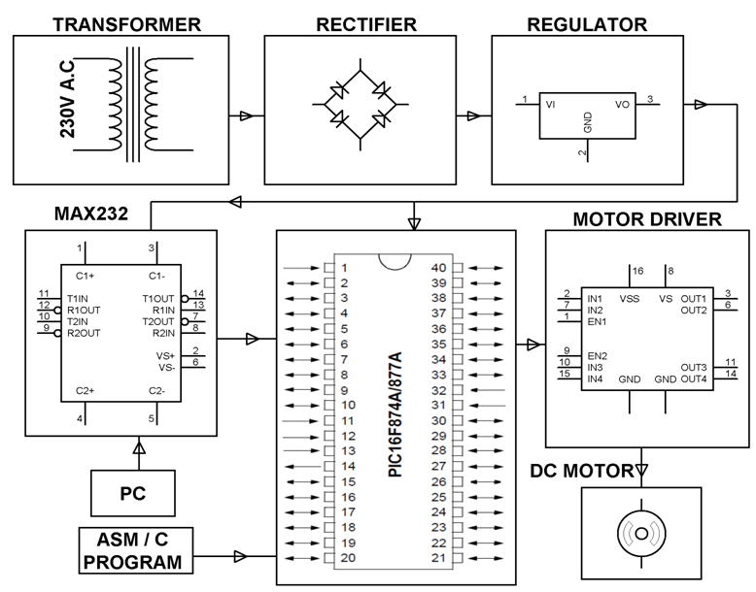

HARDWARE REQUIREMENTS:
PIC series Microcontroller, Level Shifter IC, Motor Driver IC, DC motor, Transformer, Regulator, Crystal, Resistors, Capacitors, Diodes, and LED.

SOFTWARE REQUIREMENTS:
HI-TECH PICC Tool suite
Language: Embedded C or Assembly

